UNIVERSITI TEKNOLOGI MARA (UiTM)

CAWANGAN KEDAH, KAMPUS SUNGAI PETANI

SCHOOL OF INFORMATION SCIENCE

COLLEGE OF COMPUTING, INFORMATICS AND MATHEMATICS

DIPLOMA IN INFORMATICS LIBRARY [CDIM144]

PROGRAMMING FOR LIBRARIES [IML208]

INDIVIDUAL PROJECT: MOVIE TICKET BOOKING SYSTEM

PREPARED BY:

|  |  |
| --- | --- |
| NAME | STUDENT ID |
| NURAINA HANANI BINTI MOHD ZAMRI | 2023483098 |

PREPARED FOR:

ENCIK MOHD FIRDAUS BIN MOHD HELMI

SUBMISSION DATE:

18TH DECEMBER 2024

**ACKNOWLEDGEMENT**

Assalamualaikum w.b.t

Alhamdulillah, firstly we would like to thank Allah SWT for giving strength to us to complete our group assignments easily. Without His mercy, we will not complete our assignment with ease.

We also would like to thank to our lecturer Encik Mohd Firdaus Bin Mohd Helmi, who helping us by giving the assignment instructions materials throughout this IML207 class, guiding, and correcting our mistakes during completing our assignment.

Besides, we also want to expand our thank to our classmates, IM144 3B who answering our questions in group or private chat truly give clarity to all our doubt and issues.

**TABLE OF CONTENT**

|  |  |
| --- | --- |
| **CONTENT** | **PAGE** |
| ACKNOWLEDGEMENT | iv |
| TABLE OF CONTENT | v |
| PROMPT DATA AND FUNCTION | 1 - 2 |
| CONDITIONAL STATEMENT | 3 - 4 |
| RESULT AND STRENGTH | 5 |
| KAIZEN (ROOM FOR IMPROVEMENT) | 6 |
| REFERENCE |  |

**PROJECT NAME:** Movie Ticket Booking System

**FILE NAME:** MovieTicketBooking.py

**PROMPT DATA**:

1. City: Kuala Lumpur, Kuala Selangor, Sungai Petani
2. Eligibility category price: adult price, student price, senior price
3. Movie name: Angry birds, Moana, Encanto
4. Screen: screen1, screen2, screen3, screen4
5. Time: time1, time2, time3

**FUNCTION**:

1. Create data

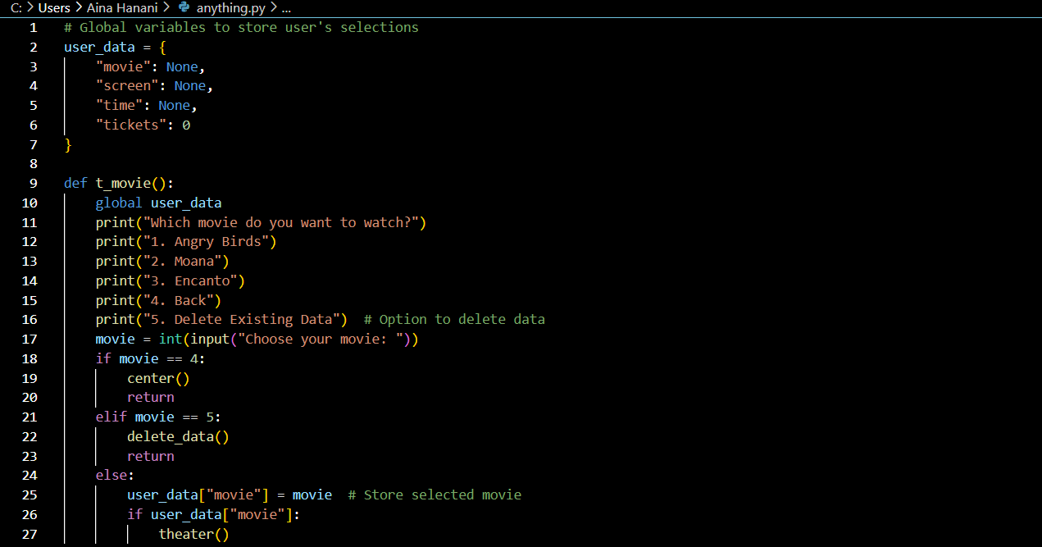

1. Read data

1

1. Update data

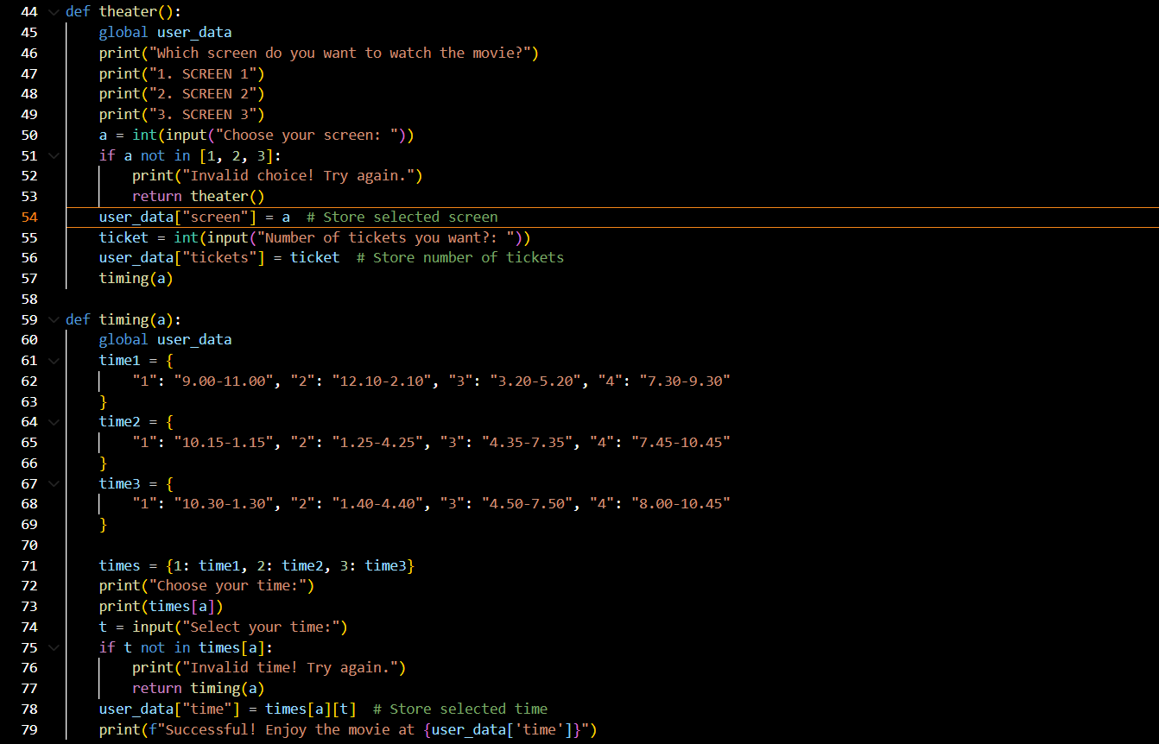

1. Delete existing data

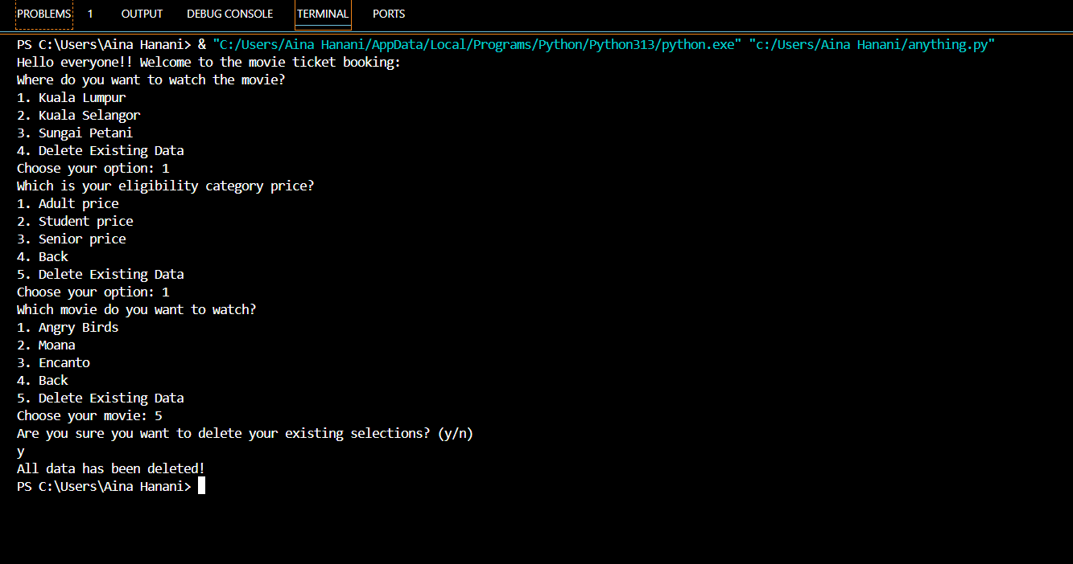

2

**CONDITIONAL STATEMENT:** Yes

1.

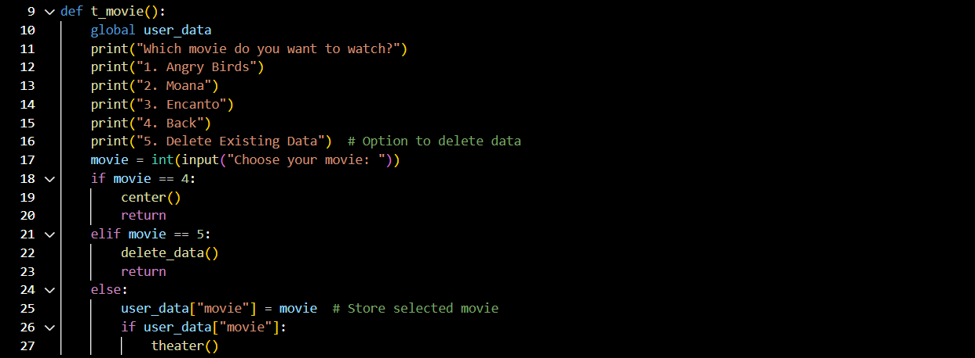

2.

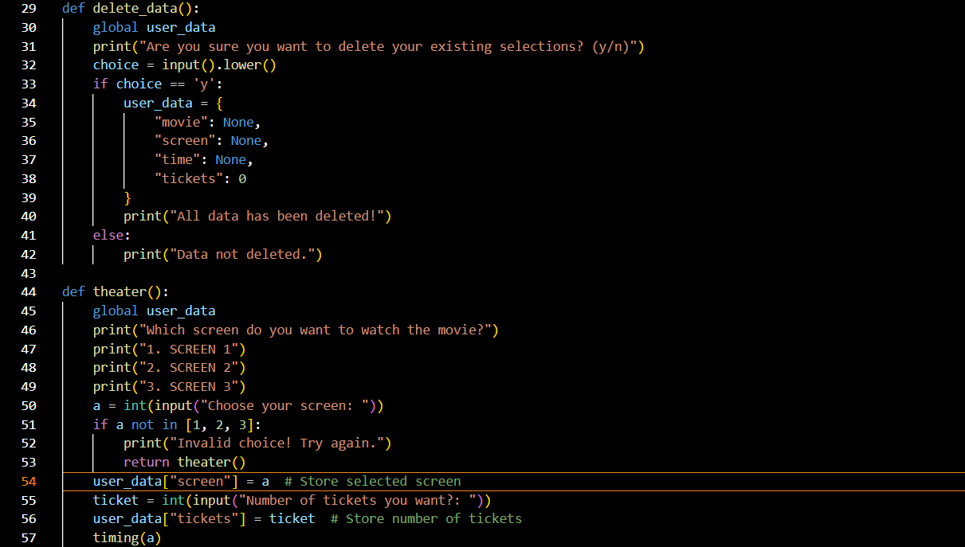

3

3.

4.

4

**GUI**: No

**RESULT:**

**STRENGTH:**

1. Movie ticket booking system can access 24/7 without needing to visit the theatre.
2. Cinema operators provide to manage showtimes, ticket eligibility and seat occupancy more effectively.
3. Provides detailed information on ticket sales, popular showtimes and revenue trends, and aiding in better decision-making.
4. E-ticket and digital booking can reduce the need for physical tickets and helping to minimize paper waste.
5. Movie ticket booking system allows for better management of ticket pricing, where prices can fluctuate based on demand, location or time of day.

5

**KAIZEN (ROOM FOR IMPROVEMENT):**

1. Provide an option for auto-suggest feature that allow users to search bar for get faster movie title, theatre or showtime lookup.
2. Provide various options to payment like integrating Google Pay or Apple Pay.
3. Display more seat selection map with clear indicators for selected a seat available and reserved.
4. Provide alerts when a movie ticket that user interested is close and selling out.
5. Offer a comprehensive FAQ section effectively to solve problems about address common issue such as payment failure and login problem.

6

**REFERENCES**

*Cinema Reservation System Essentials*. (25 December, 2023). Retrieved from Filmgrail: <https://filmgrail.com/blog/cinema-reservation-system-essentials/>

*Movie Ticket Booking management system in Python*. (12 November, 2021). Retrieved from GeeksforGeeks: <https://www.geeksforgeeks.org/movie-tickets-booking-management-system-in-python/>

*Selling Tickets Online Redefined: How a Movie Ticket Booking App Revolutionizes Event Management*. (27 February, 2024). Retrieved from Cygnis: <https://cygnis.co/blog/impact-of-a-movie-ticket-booking-app/>

Waddell, D. (12 December, 2018). *Advantages and Disadvantages of Using an Online Booking System*. Retrieved from Foreupgolf: [https://www.foreupgolf.com/advantages-and-disadvantages-of-using-an-online-booking-system/](%20https:/www.foreupgolf.com/advantages-and-disadvantages-of-using-an-online-booking-system/)